

**Spotify Cluster Analysis**

This data set contains songs from Spotify.  A start-up that plans to develop a product that generates music is interested in using the dataset to understand consumer preferences (e.g. www. HookGen.com).

Use clustering to profile the songs.

1.     How many clusters are there in the data?

2.     Describe the characteristics of the clusters you identified.

3.     What product features should be added to the product when it has to generate songs.

**Answers:**

1. According to our Cluster Analysis we have decided to go with **K = 4** and **K = 5** and have done the cluster profiling for both.

1. Following is the cluster characteristics mentioned for K= 4 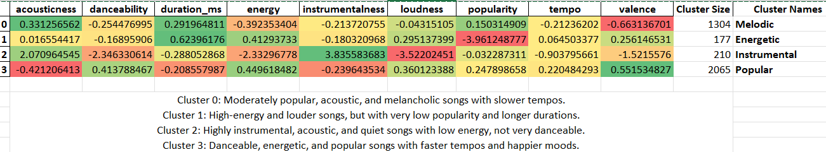

K = 5

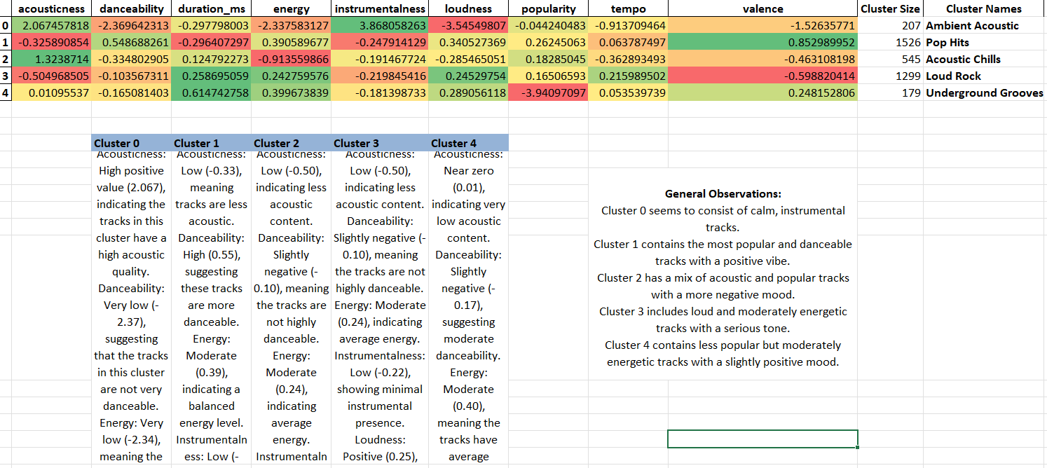

1. **What product features should be added to the product when it has to generate songs?**

**Cluster 0: Calm, Instrumental Tracks**

* **Feature**: Allow users to generate calm, instrumental music ideal for relaxation, meditation, or background music for work/study.
* **Customization**: Provide sliders or settings to adjust the acoustics and reduce the tempo to create more serene compositions.
* **Use Case**: Promote this setting for environments requiring focus or **calm, such as spas, yoga sessions, or study playlists.**

**Cluster 1: Popular and Danceable Tracks**

* **Feature**: A feature that focuses on creating popular, danceable tracks with a positive vibe, suitable for parties or social gatherings.
* **Customization**: Include options to increase danceability and maintain high energy and valence levels.
* **Use Case**: Market this feature for users looking to create music for **parties, workouts, or dance practices.**

**Cluster 2: Acoustic and Moody Tracks**

* **Feature**: Generation of acoustic tracks that may carry a more negative mood, suitable for introspective or emotional moments.
* **Customization**: Provide controls for adjusting acoustics and lowering valence to tailor music that fits more somber or reflective times.
* **Use Case**: Ideal for personal listening during **reflective moments or creating atmospheres in art exhibitions, indie cafes, etc.**

**Cluster 3: Loud and Energetic Tracks**

* **Feature**: Enable users to create loud and moderately energetic music that carries a serious tone, suitable for dramatic or impactful scenes.
* **Customization**: Sliders to adjust loudness and moderate the energy level to match different types of energetic environments.
* **Use Case**: Useful for video creators needing background tracks for **action sequences or dramatic scenes in films and games.**

**Cluster 4: Less Popular but Energetic Tracks**

* **Feature**: Focus on generating tracks that are less popular yet maintain a moderate level of energy and a slightly positive mood.
* **Customization**: Allow users to explore niche music styles that aren’t mainstream but provide a distinctive sound and feel.
* **Use Case**: Cater to niche markets or specific artistic needs, **such as background music for avant-garde fashion shows, independent films, or experimental theatre.**

**General Recommendations:**

* **Feedback Loop**: Implement a system where users can provide feedback on generated tracks, ***which helps refine algorithms and improve user satisfaction.***
* **Social Sharing**: Integrate features that allow users to ***share*** their generated music directly on ***social media or music platforms*** to ***increase engagement and attract new users.***
* **Collaboration Tools**: Enable features that ***allow multiple users to collaborate*** on a single track remotely, enhancing the tool's usability for bands and producers.
* **Analytics Dashboard**: Provide users with ***analytics*** on how their tracks are performing in ***terms of engagement and listener feedback***, helping them to make informed decisions on music production.

By aligning product features with these cluster characteristics, the tool can cater more effectively to the specific tastes and requirements of different user segments, increasing its versatility and appeal in a competitive market.